Human-Pig Hybrid Created in the Lab—Here Are the Facts

Scientists hope the chimera embryos represent key steps toward life-saving lab-grown organs.

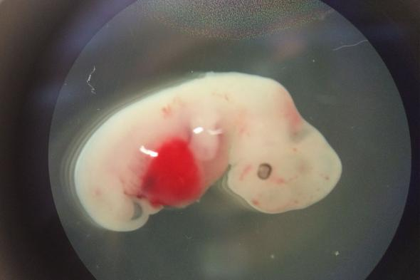
View Images
This pig embryo was injected with human cells early in its development and grew to be four weeks old.
Photograph courtesy Juan Carlos Izpisua Belmonte
By Erin Blakemore
PUBLISHED January 26, 2017
In a remarkable—if likely controversial—feat, scientists announced today that they have created the first successful human-animal hybrids. The project proves that human cells can be introduced into a non-human organism, survive, and even grow inside a host animal, in this case, pigs.
This biomedical advance has long been a dream and a quandary for scientists hoping to address a critical shortage of donor organs.
Every ten minutes, a person is added to the national waiting list for organ transplants. And every day, 22 people on that list die without the organ they need. What if, rather than relying on a generous donor, you could grow a custom organ inside an animal instead?

Watch: Pig Lungs Filter Human Blood in a Lab
Human blood filters through pig lungs in the lab of Lars Burdorf at the University of Maryland School of Medicine. Thousands of people die every year for lack of transplantable human organs. Scientists are experimenting with a technique called CRISPR to rid pig organs of viruses that harm humans.
That’s now one step closer to reality, an international team of researchers led by the Salk Institute reports in the journal Cell. The team created what’s known scientifically as a chimera: an organism that contains cells from two different species. (Read more about the DNA revolution in National Geographic magazine.)
In the past, human-animal chimeras have been beyond reach. Such experiments are currently ineligible for public funding in the United States (so far, the Salk team has relied on private donors for the chimera project). Public opinion, too, has hampered the creation of organisms that are part human, part animal.
But for lead study author Jun Wu of the Salk Institute, we need only look to mythical chimeras—like the human-bird hybrids we know as angels—for a different perspective.
“In ancient civilizations, chimeras were associated with God,” he says, and our ancestors thought “the chimeric form can guard humans.” In a sense, that’s what the team hopes human-animal hybrids will one day do.

Building a Chimera
There are two ways to make a chimera. The first is to introduce the organs of one animal into another—a risky proposition, because the host’s immune system may cause the organ to be rejected.
The other method is to begin at the embryonic level, introducing one animal’s cells into the embryo of another and letting them grow together into a hybrid.
It sounds weird, but it’s an ingenious way to eventually solve a number of vexing biological problems with lab-grown organs.
When scientists discovered stem cells, the master cells that can produce any kind of body tissue, they seemed to contain infinite scientific promise. But convincing those cells to grow into the right kinds of tissues and organs is difficult.
Cells must survive in Petri dishes. Scientists have to use scaffolds to make sure the organs grow into the right shapes. And often, patients must undergo painful and invasive procedures to harvest the tissues needed to kick off the process.
At first, Juan Carlos Izpisua Belmonte, a professor in the Salk Institute’s Gene Expression Laboratory, thought the concept of using a host embryo to grow organs seemed straightforward enough. However, it took Belmonte and more than 40 collaborators four years to figure out how to make a human-animal chimera.
To do so, the team piggybacked off prior chimera research conducted on mice and rats.
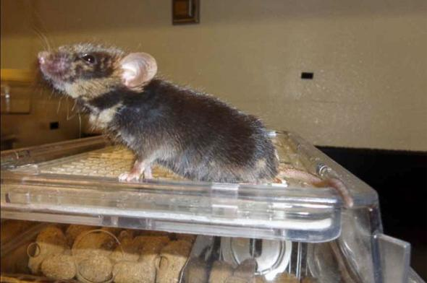
View Images
This one-year-old chimera sprang from a mouse injected with rat stem cells.
Photograph courtesy Juan Carlos Izpisua Belmonte
Other scientists had already figured out how to grow the pancreatic tissue of a rat inside a mouse. On Wednesday, that team announced that mouse pancreases grown inside rats successfully treated diabetes when parts of the healthy organs were transplanted into diseased mice.
The Salk-led group took the concept one step further, using the genome editing tool called CRISPR to hack into mouse blastocysts—the precursors of embryos. There, they deleted genes that mice need to grow certain organs. When they introduced rat stem cells capable of producing those organs, those cells flourished.
The mice that resulted managed to live into adulthood. Some even grew gall bladders, which haven’t been part of the species for 18 million years.

Rejection Risk
The team then took stem cells from rats and injected them into pig blastocysts. This version failed—not surprisingly, since rats and pigs have dramatically different gestation times and evolutionary ancestors.
But pigs have a notable similarity to humans. Though they take less time to gestate, their organs look a lot like ours.
Not that these similarities made the task any easier. The team discovered that, in order to introduce human cells into the pigs without killing them, they had to get the timing just right.
“We tried three different types of human cells, essentially representing three different times” in the developmental process, explains Jun Wu, a Salk Institute scientist and the paper’s first author. Through trial and error, they learned that naïve pluripotent cells—stem cells with unlimited potential—didn’t survive as well as ones that had developed a bit more.
When those just-right human cells were injected into the pig embryos, the embryos survived. Then they were put into adult pigs, which carried the embryos for between three and four weeks before they were removed and analyzed.
In all, the team created 186 later-stage chimeric embryos that survived, says Wu, and “we estimate [each had] about one in 100,000 human cells.”
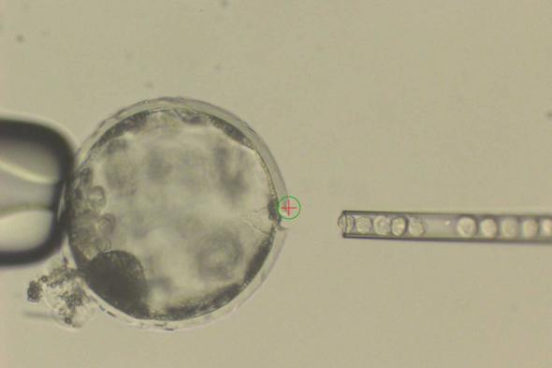
View Images
An image of a pig blastocyst being injected with human cells.
Photograph courtesy Juan Carlos Izpisua Belmonte
That’s a low percentage—and it could present a problem for the method in the long run, says Ke Cheng, a stem cell expert at the University of North Carolina at Chapel Hill and North Carolina State University.
The human tissue appears to slow the growth of the embryo, notes Cheng, and organs grown from such embryos as they develop now would likely be rejected by humans, since they would contain so much pig tissue.
The next big step, says Cheng, is to figure out whether it's possible to increase the number of human cells the embryos can tolerate. The current method is a start, but it still isn't clear if that hurdle can be overcome.
Belmonte agrees, noting that it could take years to use the process to create functioning human organs. The technique could be put to use much sooner as a way to study human embryo development and understand disease. And those real-time insights could be just as valuable as the ability to grow an organ.
Even at this early stage, Cheng calls the work a breakthrough: “There are other steps to take,” he concedes. “But it’s intriguing. Very intriguing.”

