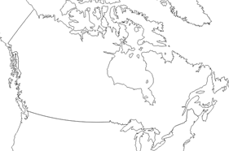
Climate Assignment
It is difficult to combine all six of these factors to analyze climate patterns and predict weather. Climate and weather specialists need a lot of training to make accurate forecasts! We will examine these factors individually to help us understand.
- Mark Hanover, Edmonton, Windsor, and Yellowknife on this map of Canada.

- Use your climographs, atlas, worksheets, and problem-solving skills to complete this table.

 | Hanover | Edmonton | Windsor | Yellowknife
Based on latitude, rank the towns from warmest to coldest.
Will any of these cities be influenced by ocean currents? If so, name the current.
Use the correct short-forms to identify the type of air mass you expect to find in each town.
Use your atlas to find the approx. elevation of each town.
Based on the elevation, rank the towns from coldest to warmest.

 | Hanover | Edmonton | Windsor | Yellowknife
Looking at a topographic of map, determine whether each town would be in the windward or leeward region (with respect to local hills and mountains).
Examine the bodies of water near each town. Do you predict the town will show maritime, continental, or modified continental climate? Why?
Calculate the annual temperature range

Calculate the total annual precipitation

Compare the temperature range and annual precipitation to the values for Vancouver and Regina. Now which type of climate do you think each town represents?

